SIMATS ENGINEERING (SAVEETHA SCHOOL OF ENGINEERING)
Department of Computer Science and Engineering
CO2 ASSESSMENT TOOL 2 – Architecture Design Assignment

Course Code: | CSA10 / CSA1021 | Course Title: | Software Engineering
CO Assessed: | CO2 | Assessment: | Assessment Tool 2 – Architecture Design Assignment
Weightage: | 20% | Total Marks: | 25
CO2 Statement: | Perform detailed requirements analysis, design scalable architectures, and prioritize features with a focus on cross-disciplinary skills
Student Name: | M.Joshna | Reg. No.: | 192472030
Date: | 30/10/2026 | Duration: | 60 minutes

Code of Conduct
I _M.joshna_192472030_(Name / Reg No) certify that this submission is my original work and that I have adhered to the guidelines specified for this assessment. I understand that any violation of academic integrity rules will result in disciplinary action.
Signature of the Student: _____M.Joshna____________________
Annexure A – Architecture Design Assignment
Instructions to Students:
Each student will be assigned an individual software project problem statement. Based on the assigned problem, analyze the system requirements and design an appropriate software architecture by applying software engineering principles. Your submission should demonstrate your ability to select, justify, and evaluate a suitable architectural style.

Question
Based on your assigned problem statement, perform an Architecture Design Analysis and prepare an architecture design report by answering the following questions:

1. Analyze System Requirements
- Study the given problem statement and identify the system objectives.
- Analyze the functional and non-functional requirements that influence the software architecture.
- Identify key quality attributes such as scalability, maintainability, reliability, availability, performance, and security.

2. Select a Suitable Software Architecture
- Select an appropriate architectural style for the proposed system (e.g., Layered Architecture, Client-Server, MVC, Microservices, Event-Driven, Service-Oriented Architecture, Serverless, or Hybrid Architecture).
- Justify why the selected architecture is the most suitable for the given problem.

3. Draw the Software Architecture Diagram
- Design a clear architecture diagram illustrating the overall structure of the proposed system.
- Include all major layers/components, databases, external systems, APIs, and communication mechanisms.
- Use appropriate software architecture notations and labels.

4. Explain Components and Their Interactions
- Describe the purpose and responsibilities of each architectural component.
- Explain how the components communicate and exchange data.
- Illustrate the overall workflow of the system.

5. Discuss Quality Attributes
Evaluate how the proposed architecture addresses the following aspects:
- Scalability
- Security
- Performance
- Reliability
- Maintainability
- Availability

6. Justify Architectural Decisions
- Explain the rationale behind your architectural choices.
- Discuss the trade-offs considered while selecting the architecture.
- Explain how the chosen architecture supports future enhancements, system integration, and long-term maintainability.
Rubrics for Calculation
Evaluation Criteria | Excellent (4 Marks) | Good (3 Marks) | Satisfactory (2 Marks) | Needs Improvement (1 Mark)
System Requirement Analysis (30%) | Thoroughly analyzes the problem statement, accurately identifies functional and non-functional requirements, and clearly explains quality attributes influencing the architecture. | Analyzes most requirements with minor omissions or limited explanation. | Identifies only basic requirements with partial analysis. | Requirement analysis is incomplete, inaccurate, or lacks clarity.
Selection of Software Architecture (25%) | Selects the most appropriate architectural style with strong technical justification aligned to system requirements. | Selects a suitable architecture with reasonable justification. | Architecture is partially suitable with limited justification. | Inappropriate architecture selected or justification is missing.
Architecture Diagram and Component Design (20%) | Produces a clear, complete, and well-structured architecture diagram with all major components, interfaces, and interactions accurately represented. | Diagram is mostly complete with minor omissions or notation issues. | Diagram includes only essential components and lacks sufficient detail. | Diagram is incomplete, unclear, or technically incorrect.
Component Interaction and Quality Attribute Analysis (15%) | Clearly explains component responsibilities, interactions, and thoroughly discusses scalability, security, performance, reliability, maintainability, and availability. | Explains most components and quality attributes with minor gaps. | Provides limited explanation of interactions and addresses only some quality attributes. | Component interactions and quality attributes are poorly explained or missing.
Architectural Justification and Technical Presentation (10%) | Provides strong justification for architectural decisions, discusses trade-offs and future enhancements, and presents a well-organized, professional report. | Provides adequate justification with minor gaps; report is well organized. | Limited justification with minimal discussion of trade-offs or future scope; report needs improvement. | Justification is weak or absent; report lacks organization and technical clarity.

Criteria | Mark
System Requirement Analysis (30%) | /5
Selection of Software Architecture (25%) | /5
Architecture Diagram and Component Design (20%) | /5
Component Interaction and Quality Attribute Analysis (15%) | /5
Architectural Justification and Technical Presentation (10%) | /5
TOTAL | /25

Architecture Design Analysis Report

Project Title: Fitness Tracking Web Application

1. Analyze System Requirements

1.1 Introduction
The Fitness Tracking Web Application is a web-based system designed to help users monitor and manage their daily fitness activities. It allows users to register, log in, record workouts, track calories burned, monitor exercise duration, and view their fitness progress through a dashboard.
The system uses a web interface for users, a backend to process requests, and a database to store fitness information. The main objective is to provide an easy-to-use platform that encourages users to maintain a healthy lifestyle and achieve their fitness goals.

1.2 System Objectives
The main objectives of the Fitness Tracking Web Application are:
- To allow users to create accounts and securely log in.
- To record daily exercises, workout duration, and calories burned.
- To monitor fitness progress through dashboards and reports.
- To help users set fitness goals and track their achievements.
- To store and manage user fitness data securely.
- To provide a simple and user-friendly interface.
- To support future improvements, such as wearable device integration.

1.3 Functional Requirements
Functional requirements describe the operations performed by the system.
- User Registration: Users can create an account using their details.
- User Login: Registered users can securely access their accounts.
- Profile Management: Users can update their personal and fitness information.
- Activity Tracking: Users can record exercises, walking, running, and other physical activities.
- Workout Management: Users can add, edit, and delete workout records.
- Calorie Tracking: The system estimates calories burned based on available activity information.
- Goal Setting: Users can set daily or weekly fitness targets.
- Progress Monitoring: Users can view fitness history and progress through charts and summaries.
- Dashboard: The application displays important fitness information in one place.
- Data Storage: The system stores user profiles, workout records, goals, and progress information

.

1.4 Non-Functional Requirements
Non-functional requirements describe the quality and performance expected from the system.
- Scalability: The application should support an increasing number of users.
- Security: User accounts and fitness records must be protected from unauthorized access.
- Performance: Pages, dashboards, and workout records should load quickly.
- Reliability: The system should process and store fitness records correctly.
- Availability: Users should be able to access the application whenever the service is available.
- Maintainability: Developers should be able to modify and update individual components easily.
- Usability: The application should be simple to understand and operate.
- Compatibility: The application should work on common web browsers and different screen sizes.

1.5 Key Quality Attributes
The important quality attributes influencing the architecture are:
- Scalability: Supports growth in users and fitness records.
- Maintainability: Separates the user interface, business logic, and database operations.
- Reliability: Uses data validation, error handling, and database transactions.
- Availability: Uses appropriate hosting, backups, and recovery procedures.
- Performance: Uses efficient queries and optimized application logic.
- Security: Uses authentication, authorization, input validation, and secure communication.

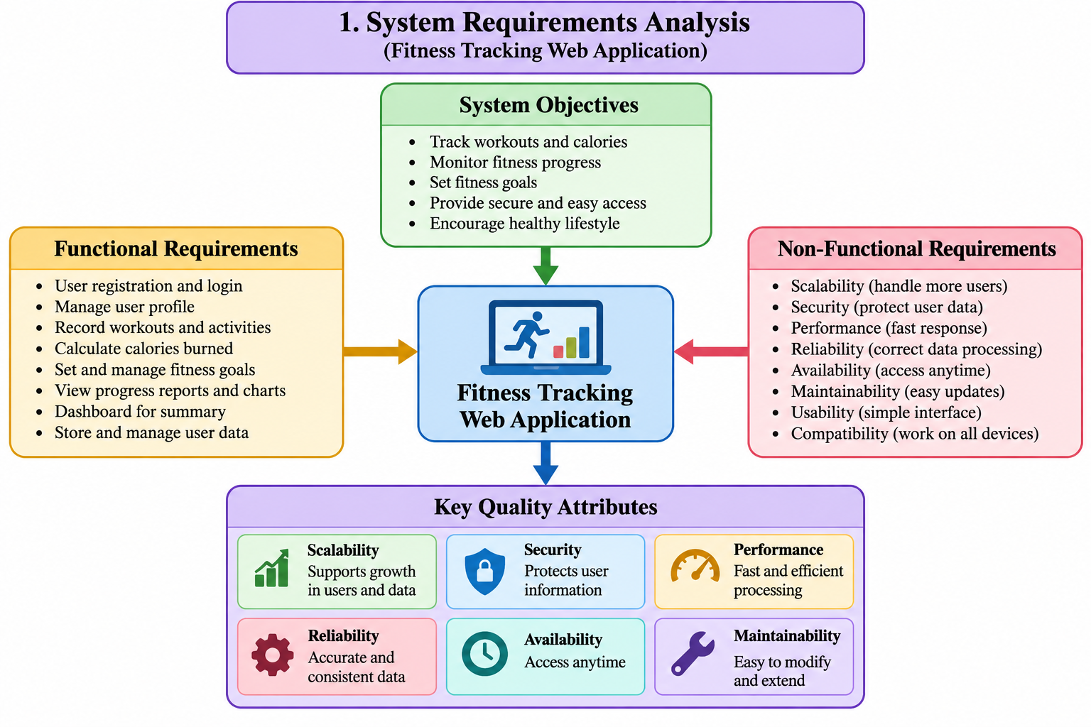

2. Select a Suitable Software Architecture

2.1 Selected Architecture: Layered Architecture
The proposed Fitness Tracking Web Application uses a Layered Architecture, organized into three main layers:
- Presentation Layer
- Application or Business Logic Layer
- Data Access Layer
A relational database stores the application's information. The application can be implemented using HTML, CSS, and JavaScript for the frontend, Python Flask for the backend, and MySQL for database management.

2.2 Explanation of the Selected Architecture
1. Presentation Layer
This layer provides the interface through which users interact with the application. It includes registration and login pages, the fitness dashboard, workout forms, goal-setting pages, and progress charts.
2. Application or Business Logic Layer
This layer processes user requests and applies the application's rules. It manages authentication, workout records, calorie estimates, fitness goals, and progress calculations. Flask can be used to implement these operations and expose API endpoints.
3. Data Access Layer
This layer communicates with the database. It performs operations such as inserting workout records, retrieving user information, updating fitness goals, and generating progress summaries.
4. Database Layer
The database stores user accounts, profiles, workout details, activity records, fitness goals, and progress history.

2.3 Justification for Selecting Layered Architecture
Layered Architecture is suitable for this project for the following reasons:
- Simple Design: The architecture is easy to understand and implement for a college-level project.
- Separation of Responsibilities: Each layer performs a specific function.
- Easy Maintenance: Changes to the user interface can usually be made without rewriting database operations.
- Data Security: Access to the database can be controlled through the backend.
- Code Reusability: Common functions, such as authentication and workout management, can be reused.
- Future Expansion: New features, such as wearable device integration and personalized fitness recommendations, can be added without redesigning the entire system.
Therefore, Layered Architecture provides a practical balance between simplicity, security, maintainability, and future development.

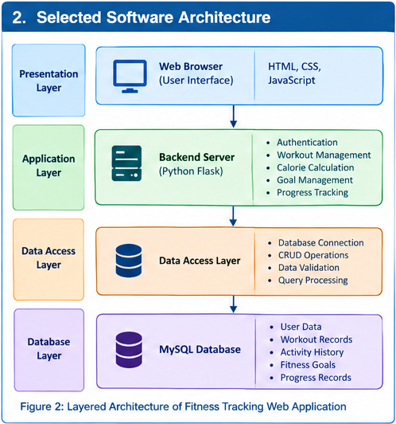

3. Draw the Software Architecture Diagram
The following diagram represents the proposed three-layer architecture of the Fitness Tracking Web Application.

3.1 Architecture Diagram

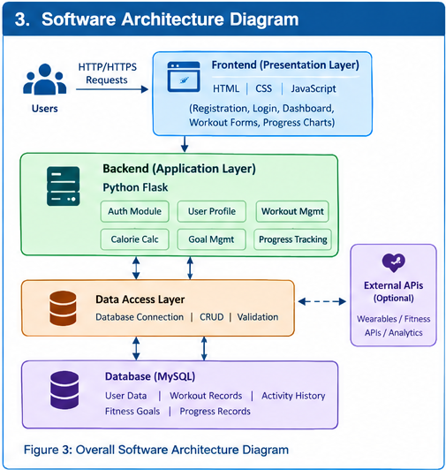

3.2 Architecture Diagram Explanation
The diagram illustrates how information flows through the system.
- Users interact with the application through the presentation layer.
- The Flask application receives requests and processes business logic.
- The data access layer communicates with the database.
- MySQL stores and retrieves the requested information.
- The processed results return through the application layer to the presentation layer.
- The user views updated fitness information on the dashboard.
This layered design separates user interaction, business processing, and data management.

4. Explain Components and Their Interactions

4.1 Purpose and Responsibilities of Each Component
The Fitness Tracking Web Application consists of different components that work together to manage user information, record workouts, calculate calories, and monitor fitness progress.
1. Presentation Layer
The presentation layer provides the user interface using HTML, CSS, and JavaScript. It allows users to register, log in, enter workout details, set fitness goals, and view progress charts. It sends requests to the backend and displays the results to users.
2. Application Layer
The application layer is developed using Python Flask. It contains the main business logic of the system. It manages user authentication, profile information, workout records, calorie calculations, fitness goals, and progress tracking.
3. Data Access Layer
The data access layer connects the application to the database. It performs database operations such as inserting, retrieving, updating, and deleting records. It also validates data and executes SQL queries.
4. Database Layer
The database layer uses MySQL to store user details, workout records, activity history, fitness goals, and progress information. It helps maintain accurate and organized fitness records.
5. External APIs
External APIs can be integrated to connect compatible wearable devices and third-party fitness applications. They can provide additional activity data and support fitness analytics and personalized recommendations.

4.2 Communication Between Components
The user interacts with the presentation layer to enter information or request fitness reports. The presentation layer sends requests to the Flask backend using HTTP/HTTPS and REST APIs. The application layer processes the requests and communicates with the data access layer.
The data access layer executes SQL queries to store or retrieve information from MySQL. The database returns the requested information to the application, which processes the results and sends them back to the presentation layer. Finally, the user views the updated fitness information on the dashboard.
The system uses authentication, authorization, HTTPS, and input validation to help protect user data.

4.3 Overall Workflow of the System
The workflow begins when a user registers or logs in to the application. The user enters workout details such as exercise type, duration, and date. The backend validates the information and calculates an estimate of calories burned. The data access layer stores the workout record in the MySQL database.
When the user opens the dashboard, the application retrieves the stored information and displays workout history, calorie estimates, fitness goals, and progress charts. This process helps users monitor their activities and evaluate their progress toward fitness goals.

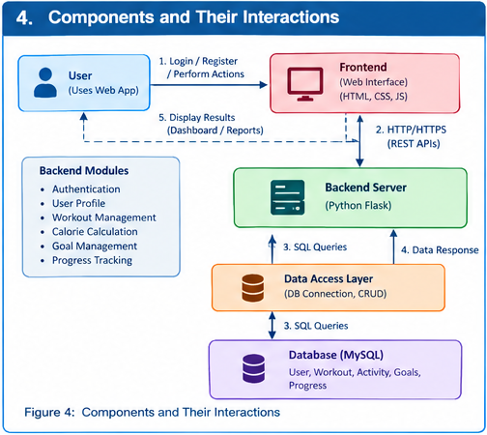

5. Discuss Quality Attributes
Quality attributes describe the overall quality, performance, and effectiveness of the Fitness Tracking Web Application.

5.1 Scalability
Scalability is the ability of the application to support an increasing number of users and fitness records. The layered architecture separates application functions and allows the backend to be upgraded or deployed across multiple servers. Database indexing and query optimization help manage growing amounts of fitness data.
For example, when more users start recording workouts, additional server capacity can be provided to handle the increased workload.

5.2 Security
Security protects user accounts and fitness information from unauthorized access. The application uses secure password hashing, authentication, authorization, HTTPS communication, and input validation. Parameterized SQL queries help prevent SQL injection attacks.
For example, users should only be able to access and modify their own fitness records unless they have specific administrative permissions.

5.3 Performance
Performance refers to the speed at which the application processes requests and displays information. Optimized database queries, indexing, caching, and efficient application logic help reduce response time.
For example, the dashboard can display a summary of daily workouts and calories burned without retrieving the user's entire workout history.

5.4 Reliability
Reliability ensures that the application performs correctly and maintains accurate fitness records. Input validation, database transactions, exception handling, error logging, and regular backups help improve reliability.
For example, if a workout record cannot be saved, the system should display an appropriate error message rather than incorrectly confirming that the record was stored.

5.5 Maintainability
Maintainability refers to how easily the application can be modified, corrected, and improved. The layered architecture separates the presentation, business logic, and database operations. This separation makes testing, debugging, and updating individual components easier.
For example, developers can modify the calorie calculation method without redesigning the entire user interface.

5.6 Availability
Availability refers to the ability of users to access the application when required. Reliable hosting, application monitoring, regular backups, and recovery procedures help improve availability. Multiple application instances and failover mechanisms can be introduced when higher availability is required.
For example, if one application server fails, another healthy server can continue processing requests when the system is configured with redundancy.

5.7 Summary
The proposed architecture supports scalability through server expansion, security through authentication and protected communication, performance through optimized processing, reliability through error handling and data validation, maintainability through modular design, and availability through monitoring and recovery mechanisms.
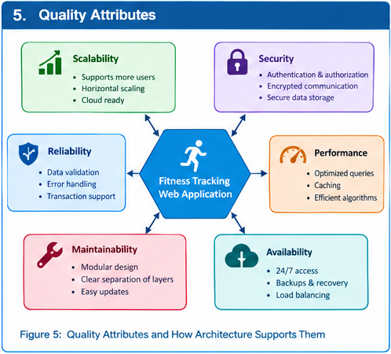

6. Justify Architectural Decisions

6.1 Rationale Behind Architectural Choices
Layered Architecture is selected for the Fitness Tracking Web Application because it separates the system into presentation, application, data access, and database layers.
This architecture is simple to understand, implement, and maintain. Each layer has a specific responsibility, which reduces code complexity and improves organization. The application layer controls business logic, while the data access layer manages database communication.
The architecture also supports testing, code reuse, and secure access to fitness information. Therefore, it is suitable for developing a college-level web application with features such as user registration, workout tracking, calorie calculation, and progress monitoring.

6.2 Trade-Offs Considered
Layered Architecture offers several advantages, including simple implementation, clear separation of responsibilities, easy testing, and maintainability. It is suitable for small and medium-sized applications.
However, requests may pass through multiple layers, which can introduce some processing overhead. A large application may also become difficult to manage if too much business logic is placed in a single backend. Scaling individual features independently may be more difficult than in a microservices architecture.
These limitations can be addressed through code optimization, modular development, database indexing, caching, and additional server capacity when required.

6.3 Support for Future Enhancements
The selected architecture supports future improvements without requiring a complete redesign of the application.
New features, such as wearable device integration, nutrition tracking, AI-based workout recommendations, advanced analytics, and notification services, can be added as separate modules.
REST APIs can support communication with mobile applications and compatible third-party fitness services. Cloud deployment and load balancing can be introduced to support an increasing number of users.

6.4 Support for System Integration
The application can integrate with external systems through APIs. Wearable devices can provide supported activity information, notification services can send reminders, and analytics services can generate additional fitness reports.
The backend can validate and process information received from these services before storing it in the database. Appropriate authentication and authorization must be applied to protect user information.

6.5 Long-Term Maintainability
The layered architecture supports long-term maintenance by separating the user interface, business logic, and database operations. Developers can test and update individual components without unnecessarily affecting the entire system.
Clear documentation, reusable functions, automated testing, version control, and regular database backups can further improve maintainability.
As the application grows, selected modules can be separated into independent services if there is a clear need for independent deployment or scaling.

6.6 Conclusion
Layered Architecture is an appropriate choice for the Fitness Tracking Web Application because it provides a simple, organized, secure, and maintainable structure. It supports the application's current requirements while allowing future enhancements and integration with external services. Although additional infrastructure may be needed to support large numbers of users, the architecture provides a strong foundation for long-term development.

